Canaan welcomes new health office BY RUTH EPSTEIN Republican-American March 30, 2022

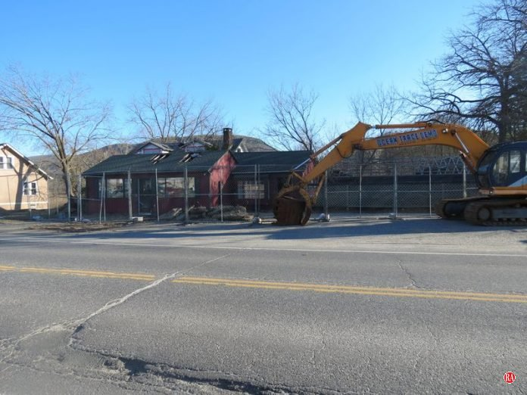
The future site of the Canaan office of Community Health and Wellness Center is on Route 44 across from Stop & Shop. Ruth Epstein Republican-American

CANAAN – Community Health and Wellness Center’s planned new office in this town received a warm response at Tuesday’s meeting of the Canaan Exchange Club.
Joanne Borduas, CEO of the Torrington-based center, gave a presentation to club members and guests who filled the dining room at Geer Lodge. The proposed 7,400 square-foot, two-story structure will be on Route 44 across from Stop & Shop and next to Canaan Fire Company’s firehouse. The federally qualified health center will offer behavioral services on the first floor and medical procedures on the second. One large room will be flexible to allow for community meetings. Parking will be in back of the building.
Borduas said the new office will have one doctor, one nurse and a chiropractor. There also will be a licensed clinical social worker in the behavioral health area. There will be no dental, imaging or obstetric services offered. It will not be an urgent care facility because that would require being open all the time.
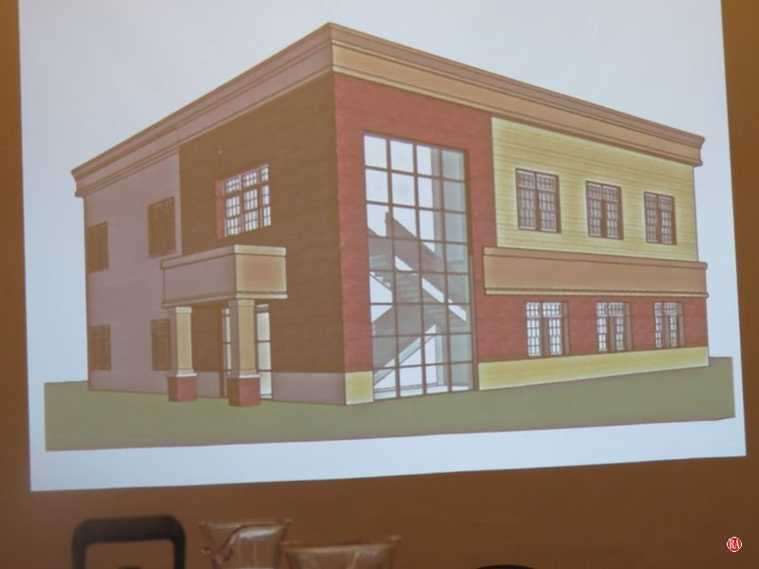A rendering of Community Health and Wellness Center’s new office that will be built on Route 44 in Canaan. Ruth Epstein Republican-American
The plan is to have the center open weekdays from 8:30 a.m. to 5:30 p.m., but that may change slightly depending on the needs of the community, Borduas said. Staff recruitment in health care is a challenge, Borduas acknowledged, but as a FQHC, the facility is eligible to participate in some programs that can help in that effort.
An old building on the site has to be demolished before construction can begin, and that process should start next week, Borduas said. A groundbreaking is planned for August and the facility is expected to take a year to complete, but pandemic delays may hamper obtaining some materials.
Borduas recognized those who have helped bring a center to Canaan, including the Foundation for Community Health, which gave $1.3 million to the project, and state Rep. Maria Horn, D-Salisbury, who is working to get government bonding. Borduas also thanked Berkshire Taconic Community Foundation and the Canaan Board of Selectmen.
Joanne Borduas, CEO of Community Health and Wellness Center, addresses a meeting of the Canaan Exchange Club on Tuesday about the center opening an office in Canaan. Ruth Epstein Republican-American
She said the mission of an FQHC is to keep communities healthy in a compassionate, high-quality way. Service is provided without discrimination and no one is turned away “because health is a right, not a privilege,” she said. Payment is on a sliding scale.
Community Health and Wellness was founded in 1998 as part of a clinic at Charlotte Hungerford Hospital in Torrington and was based at Brooker Memorial. It became a standalone center in 2002 and an FQHC in 2009. There are 17 FQHCs in Connecticut serving medically underserved areas and populations. Borduas said the aim is to provide “one-stop medical care.”
The center has locations in Torrington, Winsted, all Torrington public schools, and the FISH shelter and Community Kitchen, both in Torrington. It has received several recognitions for its quality of service.
Aware of the lack of transportation in the Northwest Corner, the center’s administrators created BETTY, a retrofitted ambulance that “brings care to where people live, work and play,” Borduas said. The medical van already makes stops at Sharon Hospital, Fishes and Loaves in Canaan, and there are plans to extend its presence to Cornwall, Kent and Salisbury.

